**It was with great sadness that the British Endodontic Society learnt of the sudden death of Mr Chris Stock on 27th December 2024.  Chris was an active member of the Society for many years and President of the BES from March 1982 to March 1983.  In addition to his immense contribution to the Endodontic Speciality as a whole, he gave much of his valuable time to the development of the Society as well as participating and speaking at its conferences.**

**Chris was one of the first restorative dentists to completely restrict his practice to endodontics prior to the creation of the Specialist Lists.  He was a mentor to so many over his professional career. His contributions to the speciality of endodontics in the UK and internationally, will never be forgotten.**

**His funeral will take place on Monday 3rd February at All Saints Church, Fleet.  We send our condolences to his family at this time.**

**Below is a tribute to Chris provided by Professor B S Chong**

**\*\*\*\*\*\*\*\*\*\*\*\*\*\*\***

**A Personal Tribute to Mr Chris Stock, BES President 1982-83, by Professor BS Chong**

**“I am a part of all that I have met."**

Ulysses by Alfred, Lord Tennyson.

The General Dental Council (UK) Specialist Lists were established in 1998. Therefore, it is difficult, nowadays, to imagine a time before the existence of specialisation in dentistry, much less endodontics, the Cinderella of dentistry, being recognised as a specialty in the UK.

One of my partners in private practice, Chris was a much-valued friend, and respected colleague, who until his retirement had contributed immeasurably to endodontics. For a number of years, we shared a surgery in practice. Chris’s commitments at the Eastman Dental Institute meant he occupied the surgery for 3 days a week while I had the remaining 2 days because of my position at Guy’s (now part of King’s College London).

The practice (later known as the Lister House Endodontic Practice), the first in the UK limited to endodontics, was founded in 1974 by the late Fred Harty, a Titan in the pantheon of pioneers in endodontics. The Harty Essay Prize of the British Endodontic Society (BES) is named after Fred. As demand for endodontic services grew, Chris joined the practice in 1978.

Before 1988, although there were continuing professional development, including hands-on courses, there were no postgraduate degree programmes in endodontics offered by any UK university. As one of two home students in the very first cohort to be awarded the MSc. in Endodontics, University of London, I was approached by Chris and joined the practice in 1990. The practice was unique because for years and prior to existence of Specialist Lists, it was the only referral group practice in the UK solely dedicated to endodontics. At its height, comprising of six partners and numerous associates, apart from the main practice in Wimpole Street, there were five other satellite practices (London Bridge Hospital, Harrow, Sutton, Southend and Fleet).

Chris, like Fred, was intrinsically linked to the BES from its infancy; Chris was the 1982-1983 BES President. Dentistry, especially endodontics, was truly a family affair with Chris’s wife, Di, providing accounting and administrative assistance for the practice and younger daughter, Sally, offering ad hoc back-office support; Di also served the BES as Society Administrator for a number of years; elder daughter, Corrie, became an orthodontist. In 2023, when the BES celebrated its 60th year, Past Presidents were invited to the anniversary dinner held on the eve of the annual Spring Scientific Meeting; this happy occasion provided the opportunity for the practice partners that attended to meet up again.

Christopher John Robert Stock graduated from St. Andrews (now Dundee Dental School) and then spent 16 years in the Royal Army Dental Corps. He obtained his MSc. in Conservative Dentistry from the Eastman Dental Institute where he was, at different times, a Senior Research Fellow and then a Senior Lecturer/Honorary Consultant. Chris was also an honorary consultant on endodontics for the British Dental Association. Generations of both home and overseas postgraduate students at the Eastman Dental Institute benefitted from having been taught by Chris; they all went on to forge careers in academia or endodontic specialist practice.

At the Eastman Dental Institute, in addition to facilitating learning activities, Chris supervised postgraduate research projects on endodontics, in particular on ultrasonic root canal instrumentation (endosonics), leading to the publication of numerous scientific papers. Chris had also written two textbooks on endodontics. In conjunction with Carl Nehammer, *Endodontics in Practice*, first published by the British Dental Journal in 1985, almost immediately became a standard text for both undergraduate students and general practitioners; its immense popularity meant another edition was inevitable and the second edition was duly published in 1990. Furthermore, with Jack Messing, Chris published the first edition of *A Colour Atlas of Endodontics* in 1988. Together with new co-editors and the title modified to *Color Atlas and Text of Endodontics*, a second edition was published in 1995. Following further editorship changes, a third edition, re-named *Endodontics*, was published in 2004.

Chris was an excellent speaker and his ability to teach clinical techniques applicable to everyday practice meant that he was in great demand and much admired for his practical wisdom. Consequently, Chris travelled the world giving lectures and running courses, disseminating endodontic knowledge and skills far and wide.

Chris also played a significant role in enhancing and advancing endodontics in Europe. In 1982, at the American Association of Endodontists Congress in Phoenix, Arizona, USA, Chris and Fred along with ten European colleagues founded the European Academy of Endodontology; subsequently, in 1983, it was renamed the European Society of Endodontology (ESE).

Chris was active in every aspect of endodontics and has left a legacy of having inspired, helped and guided many with ambitions to pursue a career in this specialty. By sharing his knowledge generously, he had highlighted the importance of endodontics and empowered clinicians in their efforts to improve the delivery of endodontic care for the benefit of patients. In his illustrious career, Chris exemplified the BES aspirations, to promote, educate and advance the field of endodontology. Chris will be fondly remembered to have been part of the movement that nurtured, advanced and enabled endodontics to develop from being a nascent dental discipline to the popular and recognised specialty that it is today.

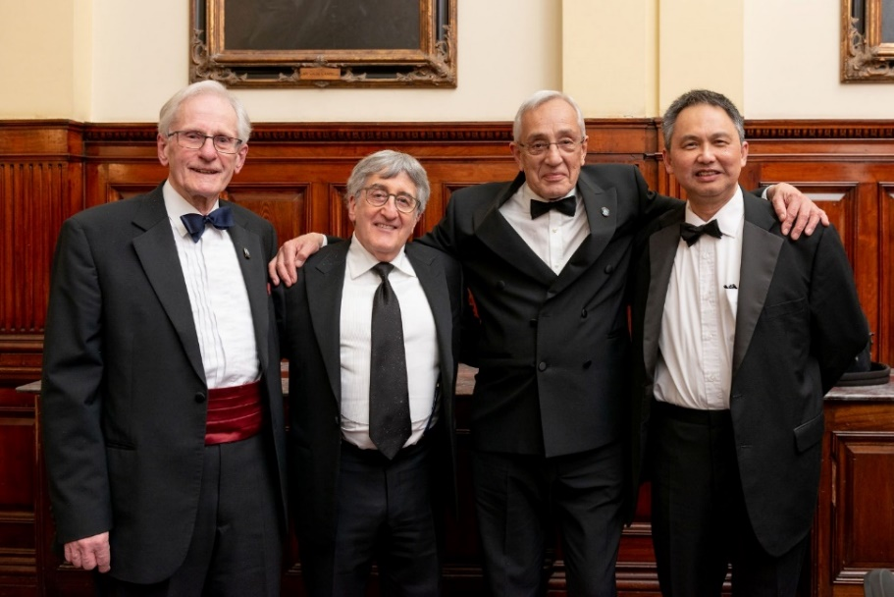

BES 60th Anniversary Dinner (from left to right; Chris Stock, Julian Webber, Carl Nehammer, BS Chong)